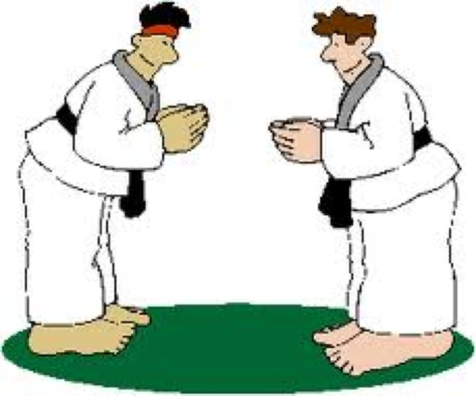

Design Document for:

The Scrum Master

“Jack of All Trades, Master of Scrum”

© 2011 by Million-Heir

By Laura Million

Version 2.2

December 15, 2011

Table of Contents

Title Page…………………………………………………………………………………1
Table of Contents………………………………………………………………….……..2
Design History……………………………………………………………………………3
Game Overview……………………..……………………………………………………4
Game Philosophy…………….……………………...…………………………….……...4
Feature Set……………………..……………………………..…………………….…….4
Genre……………………..…………………………………….…………….………......4
Target Audience………………..…………………………...……………………….….. 4
Game Flow……………………..…………………………...……………………….….. 4
Levels…………………..……………………………..………………………….…..4
Look and Feel…………………..……………………………..…………………….….. 5
Project Scope…………………..…………………………………………………….….. 5
Gameplay and Mechanics…………………………….…………………………………..6
Gameplay…………………..………………………………….………………….…..6
Purpose……………..………………………………………….......……….…….6
Object of the game………..………………………………….…………….…….6
Game Flow…………..…………………………………………………….……..6
Mechanics…………..………………………………………………………..………6
Actions……………….…………………………………………………….…….7
Screen Descriptions………..……………………………………………….…….7
Menu Screens…….………..……………………………………………….…….8
Replaying and Savings……..…………………………………………………..…….8
Story, Setting and Characters…………………………………………………………….9
Story and Setting………...……………………………………………..………..….. 9
Characters………………..……………………………………………..………..…..9
Levels…………………………………...…………………..….……...………………..10
Introduction……………..……………………………………………..……….......10
Level 1……………..…………………………………………….……..…………...10
Level 2……………..…………………………………………….……..………..….10
Level 3……………..…………………………………………….……..………..….10
Interface…………………………………………………………………………...……10
Audio, Music and Sound Effects..……………………………….……..…………..10
Help……………………………..……………………………….……..…………...10
Technical ………………..…………………………………………………………...…11
Game Art……………………………..………………………………………………,,,.11
Schedule……………………………..………………………………………………….11
Appendixes ……………………...……………………………………………….……..12

Design History

Version | Date | Changes
Version 1.0 | December 2, 2011 | First Draft of document
Version 2.0 | December 12, 2011 | Correct spelling and grammar
Version 2.1 | December 15, 2011 | Added more descriptions about the Scrum.
Version 2.2 | December 15, 2011 | Final Proof of the document

Game Overview
You read about Scrum, you heard about its success. Now you want to find out more about it but will it work with your projects? Who is involved in Scrum and how is it organized? What roles do each of the team members play? These questions and many more will be answered when you play this game.

Game Philosophy
There is no better way to learn how to do a job than to jump in and do it but sometimes the risk of a project failing while a project manager learn the ropes is not always practical. “Scrum Master” is a game for the player to learn from their mistakes in a safe environment. “Scrum Master” is a role playing game. There will be no gun fire, no exploding bombs and no blood. That is what World of Warcraft is for. “Scrum Master” is a simulation of a real-world workplace with unexpected problems and issues for the player to solve.

Feature Set
The player will be asked to create gaming software using the Scrum framework. The player will interact with his/her virtual development teams and Product Owner. The team will present problems and issues that the player may face in a real world situation. The complexity of the problems and number of issues will depend on the level of the game the player selects.

Genre
The genre of “Scrum Master” is computer interactive role-playing game. The player will be given the role of Scrum Master and scenarios to interact with the Scrum team. The player’s skills as a Scrum Master will be developed as he advances through the levels of the game.

Target Audience
The target audience for this game is the project manager who wants to implement the Scrum framework into their projects or for existing Scrum users that want a brush up on the technique.

Game Flow
The game begins with an introduction of all the team players, their jobs and their experiences within the company. The player begins with the Introduction where he/she will learn about the roles of the Scrum Master, the Development Teams and the Production Owner. Once the player feels confident in understanding the roles of the team, he can move onto Level 1. Each level is a Sprint where the Development Team will create a product. The Player will interact with the Development Team and Product Owner. These roles will remain consistent throughout all the levels, but the avatars and their personalities will change with each level or when the player repeats a level.

Levels
Level 1 models a successful, a “perfect-world” Sprint. The player will be introduced to the interaction of a Scrum team with the Product Owner and the development team. The player will be introduced to a Sprint where the development team will successfully create a project under the guidance of the Scrum Master (player). Level 1 will be considered finished when the Product Owner accepts the final product. The player may play Level 1 more than once. The player will have the choice to repeat the scenario or select a different scenario with the same basic components. Once the player feels confident in the understanding of the Scrum framework, he will advance on to Level 2.

Level 2 will present more real-world issues that arise in a Sprint. Team conflicts, project creep, and other delays are common in projects. In Level 2 the player will be presented with a variety of problems and issues that he is expected to overcome before advancing to the next level. Level 2 will be considered finished when the Product Owner accepts the final product. Each attempt will provide a different scenario with the new problems and issues to overcome. Once he feels confident with understanding and solving of the basic problems that affect a team, he will advance on to Level 3.

Level 3 is the Sprint from Hell! The player will encounter team members that do not adhere to the Scrum framework. He will be responsible to make sure that they understand the Scrum framework and keep the team on task. This level will test the player’s knowledge and ability to implement the Scrum framework. Level 3 will be considered finished when the Product Owner accepts the final product.

Look and Feel
The look and feel of this game will simulate a real-world team. Staff interacts and jokes with each other and with the player. The player will be presented real-world scenarios of meetings with the Product Owner where he may ask questions and receive answers. The player will attend meetings with the Development team for Sprint Planning, Daily Scrums, Sprint review and Sprint retrospect. Team members will report back to the Scrum Master with their successes or failures in the project.

Project Scope
There is an introduction section and three levels to this game, beginner, intermediate and advanced. The introduction can be reviewed at any time to refresh the player’s memory about the members of the Scrum team. Each level can be repeated with a new scenario and new issues. A player does not advance to the next level until the current level is successfully completed.

The introduction is a list of characters and their roles on the team. Each level has six rooms: the Product Owner’s office, three development team workstations, the Scrum Master’s office and a conference room for team meetings. Each room will model a real-world example.

There will be seven to nine Non Player Characters (NPC): six to eight developmental team avatars and 1 Project Owner avatar that the player interact throughout the levels. The appearance of the avatars can be customized for a new experience for each game through an avatar panel.

Gameplay and Mechanics
Gameplay
The game begins with an introduction of the company, co-workers and their jobs and the product being built. The player may choose between various avatars for coworkers or design his/her own. Once the introduction and customization is complete, the player chooses between a beginning level, intermediate level or advanced level. Once a player successfully masters a level, he has the choice to move to the next level or play that level again with a different scenario.

Purpose
The purpose of the game is to learn how to manage a Scrum team and master the different expectations of a Scrum Master. The player will be given real world scenarios faced by real-world Scrum Masters.

Objective of the Game
The objective of the game is to successfully complete a Sprint, and release a potentially workable product to the Product Owner while overcoming real world obstacles.

Game Flow
Once the player finished the introduction, creates or chooses the avatars for co-workers, and selects the level of difficulty, the player will meet with the entire Scrum team for the Sprint Planning Meeting. It will be there that the team learns the product to be produced. The player will follow prompts and coach the development team, communicate with the Product Owner and make sure that the team understands and follows the Scrum framework. The player will participate in daily Scrum meetings

When a player successfully solves an issue and avoids pitfalls, he will earn points that he can later turn in for rewards for himself and the team. Once the player delivers a workable product, he receives bonus points that the player can turn in for rewards such as a party for the team or comp time off, (all virtual, of course!)

Mechanics
Each level in the game is known as a Sprint. Every level has the same basic format. The player begins each level with a Sprint Planning meeting where the Product Owner presents the Product Backlog to the Scrum Team consisting of the Product Owner, Development Team and the Scrum Master. The Development Team works together to understand what part of the Product Backlog they will be working on during this Sprint. The team also creates the Sprint Goal which provides the guidance for the team during the building process. It is the responsibility of the Scrum Master to keep the Development Team adhering to the Scrum framework.

Once the goal is established, the Development Team works together to determine how the Product backlog will become the final product and what it means to be “done” with this portion of the project. The Development team will then report back to the Product Owner and Scrum Master with their plan.

As the play continues, the Development Team reports back to the Scrum Master their accomplishments and next goals in the Daily Scrum section of the game. Throughout the development process, the player has an opportunity to make decisions based on the problems and issues that arise within the Development Team to keep the Sprint on track.

When the Development Team delivers the “done” product, the Scrum Team reviews the product and adjusts the Product Backlog if necessary. The Development Team discusses what was successful about the product and what could be changed to improve it. The Scrum Team decides what to do for the next Sprint based on the remaining Product Backlog.

The Scrum Team then participates in the Sprint Retrospective where the Scrum Team reviews what when well and what could be improved within the Scrum team itself. The Sprint team develops a plan for improvements to the way that the Scrum Team works together and does its work. The player will have the opportunity to make suggestions for improvement based upon the discussion of the Scrum Team.

Since this game is a role playing game, the scenes that the player moves through are real world offices and work stations. As the player interacts with the avatars, the player’s decisions will determine the next step in the game. For example, when a Daily Scrum is completed, the scenario will shift to the player interacting with a development team as the team discusses with the player an issue they are experiencing.

Actions
Throughout the game, the player will have decisions to make. He will be given a choice of answers to choose from and those choices will influence the actions with the avatar. The avatar’s reactions will be random throughout the levels so that no two scenarios are the same.

The avatars speak to the player either with voice, text or both. The player will have the opportunity to switch between the three options. A reply button will be available for the avatars to repeat the conversation.

Screen Descriptions

The player’s Avatar walks in to see a team working around a computer, brainstorming ideas. The player listens to some of their ideas.
A screen appears with suggestions for the player. He selects one option to “tell” the team. | 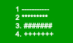
The scene changes depending on what option the player choose. They may accept the option or explain why they don’t like it.
At regular intervals, a Daily Scrum reminder will alert the player to attend the Daily Scrum meeting. | 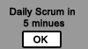
The player will enter the Daily Scrum meeting room

Menu Screens
Upon entering the game the first time, the player will be automatically taken to the introduction and avatar section. Once the preliminary information is presented, the player will have the option of selecting Beginner, Intermediate and Advanced level of play. Inside each level are buttons for reviewing the previous scene or replaying the previous scene. There is also a Main Menu dropdown box with a Save and Quit option allowing the player to leave the game but to return to finish at another time. Once a Sprint is started, the player must finish it or cancel it. Cancelling a Sprint may result in loss of points earned during that Sprint. A player must successfully complete the level before moving on to another level.

Replaying and Saving
Every scenario can be paused, stopped or replayed with a corresponding button on the play bar. A player can pause a game for up to one hour before the system will automatically save the game and log the player off. A player can stop a game and return to it at a later time. A player can replay a scenario or an entire Sprint. When the Sprint is over, the player will be prompted with three options, to continue to the next level, play the same level with a new scenario or play the same scenario over. Each scenario should take the player a total time of about one hour to complete.

The game will automatically save as the game switches from scenario to scenario. If a player chooses to leave the game, he will select the Save and Quit option from the Main Menu. When the player returns, the player will be offered the option to start where the game left off or quit current Sprint and start a new one. If the player decides to start a new Sprint a completely new scenario will be presented to the player.

Story, Setting and Characters
XYZ company has been hired to create gaming software for adults. Past experiences with gaming software have led to late deliveries, budget over costs, employee overtime and bug-filled software. At a recent conference, the CEO heard about the Scrum framework and wants the player to lead his/her team using Scrum.

Story and Setting
In the introduction phase, the player will be introduced to his/her Scrum team and learn about the first Sprint. In Level 1, the first Sprint is very basic with no major issues to get the player familiar with the Scrum framework. As the player progresses through the first Sprint, he will attend a Sprint Planning meeting which determines what will be delivered at the end of the Sprint and what work needs to be done by the team. The player will attend Daily Scrum meetings for updates on the team’s progress. In between Daily Scrum, the player will meet with the development team and the Product Owner for updates and issues that will arise within the Sprint. When the team has finished the product, the player will attend a Sprint Review with the Scrum team to determine if the product is complete. Once all is complete, the Scrum team will meet for a Sprint Retrospective to determine how successful the Sprint was. Could there be any changes? What went well and what didn’t go as well in the process?

Level 2 will progress the same as Level 1, but character personalities will enter the picture. The player may have to solve a dispute between development team members. The player may have to deal with work delays or goal creep.

Level 3 will present even more obstacles for the player to encounter. The player may actually have to deal with a situation where the Sprint needs to be cancelled or with a product that does not meet expectations.

Characters
The avatars in this game will be average game creators. The characters will be the coders, the artists and the designers as part of the development team. The Product Owner acts as the project manager. The player will be the intermediate between the two that keeps the Scrum framework going. The avatars will be customizable by the player for each level.

As the player advances through the levels, the characters will create more issues and become less willing to adhere to the Scrum Framework in order to give the player a realistic experience of different personalities the player may encounter in the real world. For example in Level 1, all the avatars work together well with no major personality issues among themselves. In one scenario the coders may be geeks and the artists scatterbrained. If the player chooses to replay the beginning level, the scenario will change and the character personalities may change, but the avatars will still work together well. When the player advances to Level 2, more personality issues will arise such as creativity conflict and missed deadlines. Level 3 will include some roadblocks such as equipment malfunctions and scheduling conflicts.

Levels
Introduction
The player will be introduced to the Scrum framework and to the various players. The player will have the option of customizing the avatars to keep the game interesting.

Level 1
Level 1 will walk the player through a model Sprint with no major personality conflicts or issues. The player will have the ability to replay Level 1 with a new scenario and new avatars.

Level 2
Level 2 will begin adding problems and issues into the Sprint. Some of the issues may include personality conflicts, late deliveries of products, change of scope or goal creep. The player will have the ability to replay Level 2 with a new scenario, new issues and new avatars.

Level 3
Level 3 will take the player through multiple issues and problems. For example, one developmental team does not want to use the Scrum framework and is fighting against it. The player will have scenarios to problem-solve and work around. The player will have the ability to replay Level 3 with a new scenario, new issues and new avatars.

Interface
Since this is a role playing game, the interface will resemble a virtual world like Second Life. Scenes will shift when the scenario moves to a different room. The player controls his/her avatar using the up/down/left/right keys to walk. The Enter key allows the player’s avatar to sit and the Shift + Enter key allow the player’s avatar to stand. The NPC avatar’s will walk and move according to the needs in the scenario.

Audio, Music and Sound Effects
The avatars will speak as needed. The player will communicate either by typing into a text box or by selecting pre-determined answers on the screen. The music and sound effects will be low key as the scenes are set in an office.

Help
There will be an extensive game help menu available on every scenario pertaining to the needs of that particular scene. Help with the player’s movements and other necessary commands will be available on all screens.

In Level 1, every time the player reaches a decision screen, an advice window will pop-up assisting the player for help in making a decision. In Level 2 and Level 3, the advice window will be an optional button.

Technical
Player Specifics
Operating systems: PC – Windows XP, Vista, Windows 7; Mac – OSX
Recommended Browsers – IE 7 and above, Firefox 3.0 and above, Safari
Internet Connection – Broadband
Screen Resolution – 1024 X 768
Memory– minimum 128MB of memory, 512MG Ram
Storage – Hard drive 50MG of space
Processor – Pentium III or faster
Keyboard & Mouse
Speakers or headphones

Game Art
The game art will be 3-D cartoon characters and scenes. The avatars will be dressed in business casual. See Appendix 1.1. The offices and meeting rooms will be designed based off of real-world offices and meeting rooms. See Appendix 1.2. The feel of this game should mirror the real-world office.

Management
Schedule
The Scrum will be used in creating this game. The following is the intended schedule:

Sprint 1: The Introduction
Sprint Planning Meeting: Monday January 2nd, 2012
Daily Sprint Meetings: Monday – Friday, 9am
Sprint Review: Monday, January 30th, 1pm
Sprint Retrospective: Tuesday, January 31st, 1pm

Sprint 2: Level 1
Sprint Planning Meeting: Wednesday, February 1st, 2012
Daily Sprint Meetings: Monday – Friday, 9am
Sprint Review: Thursday, March 1st, 1pm
Sprint Retrospective: Friday March 2nd, 1pm

Sprint 3: Level 2
Sprint Planning Meeting: Monday March 5th, 2012
Daily Sprint Meetings: Monday – Friday, 9am
Sprint Review: Monday, April 2nd, 1pm
Sprint Retrospective: Tuesday, April 3rd, 1pm

Sprint 4: Level 3
Sprint Planning Meeting: Wednesday, April 4th, 2012
Daily Sprint Meetings: Monday – Friday, 9am
Sprint Review: Thursday, May 2nd, 1pm
Sprint Retrospective: Friday May 3rd, 1pm

Appendix

Appendix 1.1
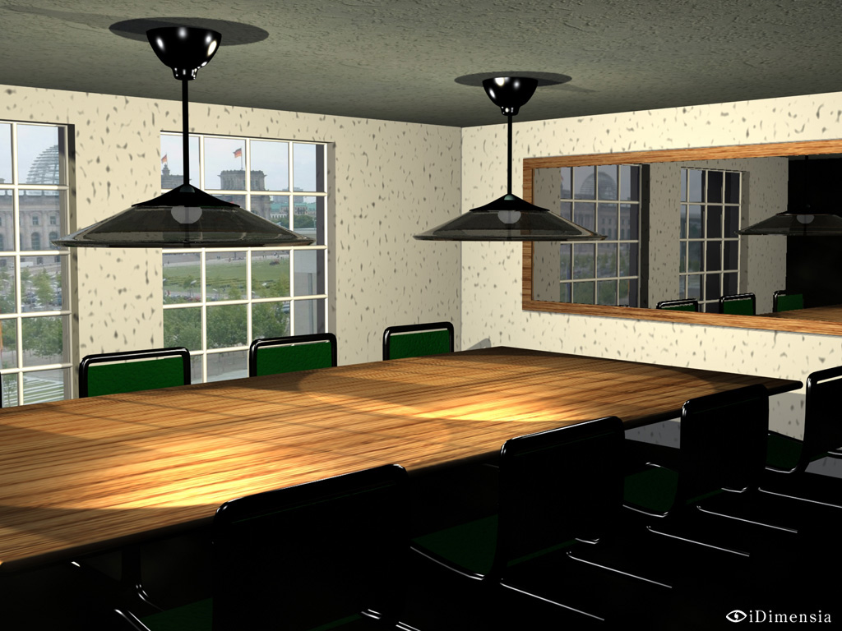

Appendix 1.2

