Download CoursEval Survey Results
Log In to CoursEval
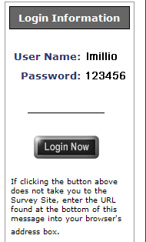
You will receive an email from CoursEval with the login information to retrieve your evaluation results.
From the email, click the Login Now button to continue.
A browser window will open with the CoursEval login page.
Using the username and password from the email (not your SIUE E-ID) fill in the boxes and click the Log In button.

View Current Semester Evaluations
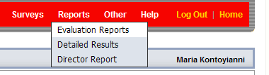
If the opening page states that you do not have any surveys, click on the Reports link in the red menu and select Evaluation Reports from the drop down list.

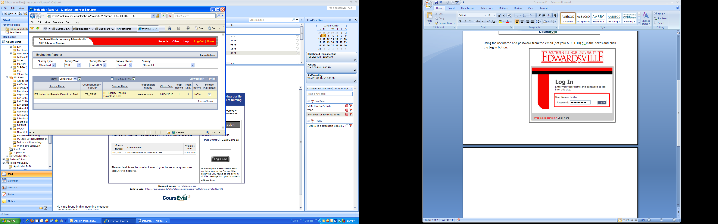
2
1
3
4
5

To see all of your evaluations for the current semester make sure that the drop down menu display:
- Survey Type: Standard
- Survey Year: The year of the Survey (2009 in the image below)
- Survey Period: The semester (Fall 2009 in the image below)
- Survey Status: Closed
- Survey: Show All ( you may have multiple surveys if you teach more than one class)

To view the Evaluation Report, check the box to the right of the evaluation. If you have more than one evaluation, you may check more than one box to view multiple evaluations at the same time. Click on View Report link.
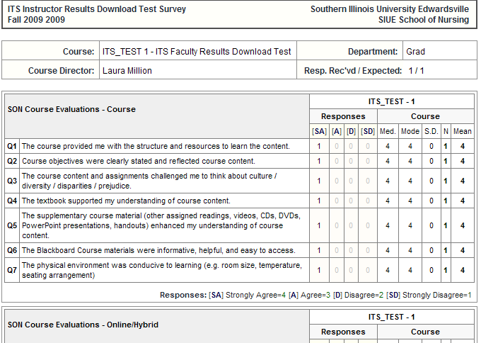

A new window will open with the report.

Print the Evaluation Report
To print the report, from the Menu bar, click File…Print or return to the CoursEval window and select the Print option next to View Report.

