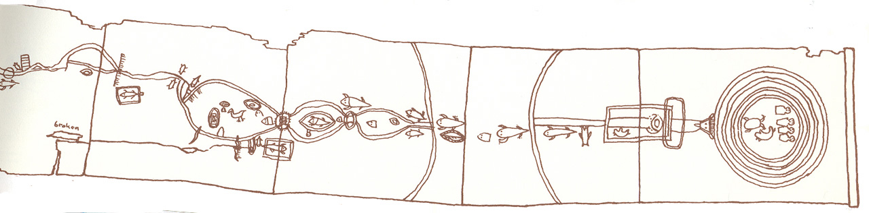

HIST 281: Winter 2021
Native and Indigenous History Since 1871

Hi, I’m Cate Denial, and I’ll be your professor this term. Welcome to the class! My pronouns are she/her/hers.

You can reach me by email at cdenial@knox.edu

I’m available from 9am-8pm M-Th and 9am to 4pm on Friday.

Saturdays and Sundays are my recharge days, so I will occasionally check my email, but cannot guarantee you a quick reply on those days.

Student Hours:

My student hours are from 9-10.30am on Tuesdays and Thursdays, and I am delighted to meet with you over Zoom at other times. Just email me to make an appointment!

Student hours are time set aside just for you. Drop by to chat about anything you want, at any time.

Introducing myself:

To introduce myself and to give you an idea of how I teach, I’ve made a website for you at http://learningincommon.org

COVID information:

Masking is required in this class at all times.

Should we need flexibility to respond to changing circumstances, you will always find the most up-to-date version of your reading schedule and homework on Classroom. This is where I will post Zoom links, should we need them.

If you are sick at any point during this term, please let me know (no need to specify your illness!) so that we can work together to make sure you have time to get well before catching up with class.

What are we here to do?

Together, we’ll examine key turning points in the history of Native people in the United States from 1871 to the present day—moments that had a profound impact upon almost all Native nations. We will take stock of the influence of federal policy on reservations, examine the experiences of children sent to boarding schools, consider what it meant to be Native during the New Deal and WWII, probe the U.S. policies of termination and relocation, and analyze American Indian sovereignty movements.

Why study this?

Many history textbooks and almost all American popular culture would have us believe that Native people ceased to exist after 1900. This profoundly distorts what we know about the United States in the 20th and 21st centuries, and allows all manner of oppressive policies and actions to go unquestioned. It also erases the history of Native peoples’ vital resistance to colonialism.

Here are our learning goals this term:

    - Understand the significance of Native history and Native voices.
    - Synthesize and interpret our knowledge about Native history for our peers.
    - Reflect on how learning Native history changes our sense of history at large, and our understanding of ourselves.
Readings:

You have two required texts for this course. Copies are available through the library, to buy from the bookstore, or to buy from any number of online retailers. Feel free to get a used copies where you can!

Daniel Heath Justice and Jean M. O’Brien, eds., Allotment Stories: Indigenous Land Relations Under Settler Siege.

Mark St. Pierre, Madonna Swan: A Lakota Woman’s Story.

All other readings will be provided to you as pdfs on our
Classroom site.

Assessment:

There are three graded assignments in this course:

- Letter to Someone 35%
- Unessay Project 35%
- Reflection 30%
TOTAL 100%

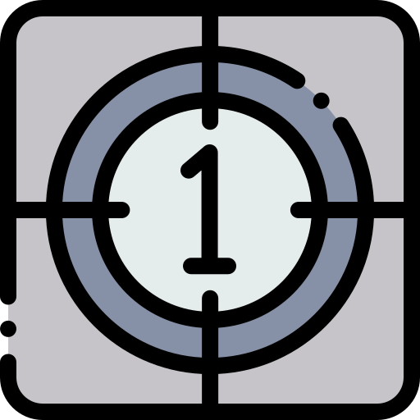
- Letter to Someone [due in Week Four]

Around midterms, I will ask you to write a letter to someone of your choosing, explaining why something you’ve studied in class is important for them to know. This letter will be 4-5 pages long.
- Unessay project [due in Week Eight]

After the middle of term, you’ll choose a subject related to Native and Indigenous history in the United States and create something of your choosing that communicates what you know about the subject. You might make a zine, create art, cook food, make a film, draw a map -- the possibilities are endless.
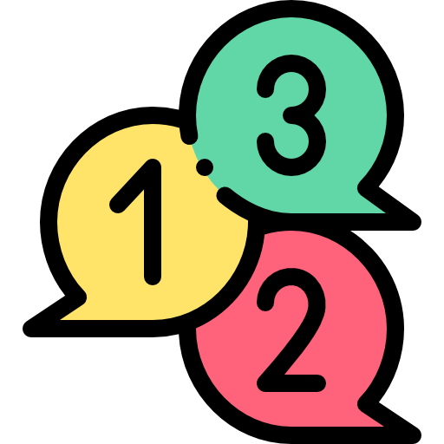
- Reflection [due during Finals]

Your final assignment this term will be a reflection on the most important things you’ve learned in this class. Your reflection will take the form of a five-page paper, or a six-minute video or audio presentation.

Need help?

If you find any aspect of this course challenging, please come talk to me. There are lots of reasons someone might experience a challenge: some people may not be familiar with the conventions of history as a discipline; some people find it hard to organize their thoughts; some people flourish when given early feedback on how their paper is shaping up. All these things – and all the other challenges it’s possible to have – are things I can help with.

The Center for Teaching and Learning also offers writing help, Monday-Friday, from 10.30am-4pm, and tutoring in the Red Room of Seymour Library on Tu/W/Th evenings from 7-9pm.

You can also make an appointment with a writing tutor by using the CTL link on my.knox.edu.

Accessibility:

I try to design my classes to be accessible to everyone, but there may be things I haven’t thought of. Please let me know if there’s something else that would help you succeed in class.

Remember that if you need an accommodation for a disability, you should contact Stephanie Grimes (309-341-7478 / sgrimes@knox.edu) at our Disability Support Services office. Stephanie will help us both figure out the very best approach to your learning, and I will make all the accommodations she recommends. I will keep all your information confidential.

Our classroom community:

Our social identities – such as our race/ethnicity, class, gender, sexual identity, religion, mental and physical ability, size, national origin, and citizenship status – can affect not only how we are understood, represented, and treated on campus and in society, but also the types of knowledge and learning seen as worthwhile and legitimate.

In this class, we’ll be analyzing the ways in which social identities condition what we assume, experience, and conclude about the world. We’ll look at the social identities we each possess, and the way social identities influence the work we’re reading, listening to, or watching.

I have included readings, topics, and assignments in our course that include authors, perspectives, and critiques from diverse backgrounds. There may be things I have not thought of, however, and I always welcome your feedback on ways this course can be made more transformative.

We will spend time creating guidelines for our conversations at the beginning of term.

Helpful Warnings

I have tried to anticipate where you may need a trigger/content warning, but if you have concerns or want to check that a particular trigger has been taken into account, please let me know. (You do not need to provide details about why the thing in question is a trigger; letting me know you need a warning for X is enough.) I am happy to provide that warning so that you can interact with class material safely, and on your own terms.

Knox holds that all faculty, staff, teaching assistants, and RAs are responsible reporters: that means if I learn of a Title IX situation from you, I must inform Kim Schrader, our director of Title IX. This does not mean that a case has been opened: you can opt not to pursue Title IX measures once you hear from our Title IX office. Please bear this in mind as we talk about difficult subjects this term.

We are all likely to have strong emotional reactions to class material, as much of it deals with profound injustice. We’ll spend some time at the beginning of term talking about the range of things we can do when we experience that kind of reaction. I do not think of you as a brain in a jar but as a whole human being. Please have a conversation with me if you feel upset, confused, or angry.

Your well-being

Please remember that learning is about more words on a page, or ideas in a classroom. To learn you need to have basic security – a roof over your head, a bed to sleep in, food to eat.

If you’re having trouble with any of those things, please talk to me and to the Dean of Students. Together we can work to make sure those needs are met. Remember that Knox has a Covid Relief Fund that can help with these issues.

You can reach Deb Southern at dsouther@knox.edu or by calling 309-341-7225.

In addition, you will be emotional learners in this classroom as well as intellectual learners, quite simply because that’s how every human learns. Don’t leave your emotions at the door. They’re important and valid and I welcome them. If you feel like you do not have emotional stability, talk to me and the Counseling Center on campus. We’ll help you find a path to feeling secure.

You can reach the counseling office at counseling@knox.edu, or by calling 309-341-7492.

The Honor System at Knox College

We commit ourselves to act with academic integrity this term – to be ethical in what we say and write, and to offer credit to others for thinking of ideas before us. I believe that everyone in my course is fundamentally honest, and I will help you learn the conventions of academic integrity, such as citing sources correctly and being clear about where our own words begin and end.

If you’d like to read more about the college’s Honor Code – which was written by students just like you, and which students co-govern with faculty – you can find a copy at this link: https://www.knox.edu/Documents/PDFs/Academics/Honor-System.pdf

All icons made by Freepik at http://www.flaticon.com.

