Air Conditioning Laboratory:

The objective of this experiment is to analyze a refrigeration cycle and to determine the cooling effect and Coefficient of Performance of an air conditioner. To further understand the concepts and ideas held in this laboratory experiment, the following references can be obtained:

- Fundamentals of Engineering Thermodynamics, Moran and Shapiro, Wiley, 5th ed. 2003, ISBN: 0471274712

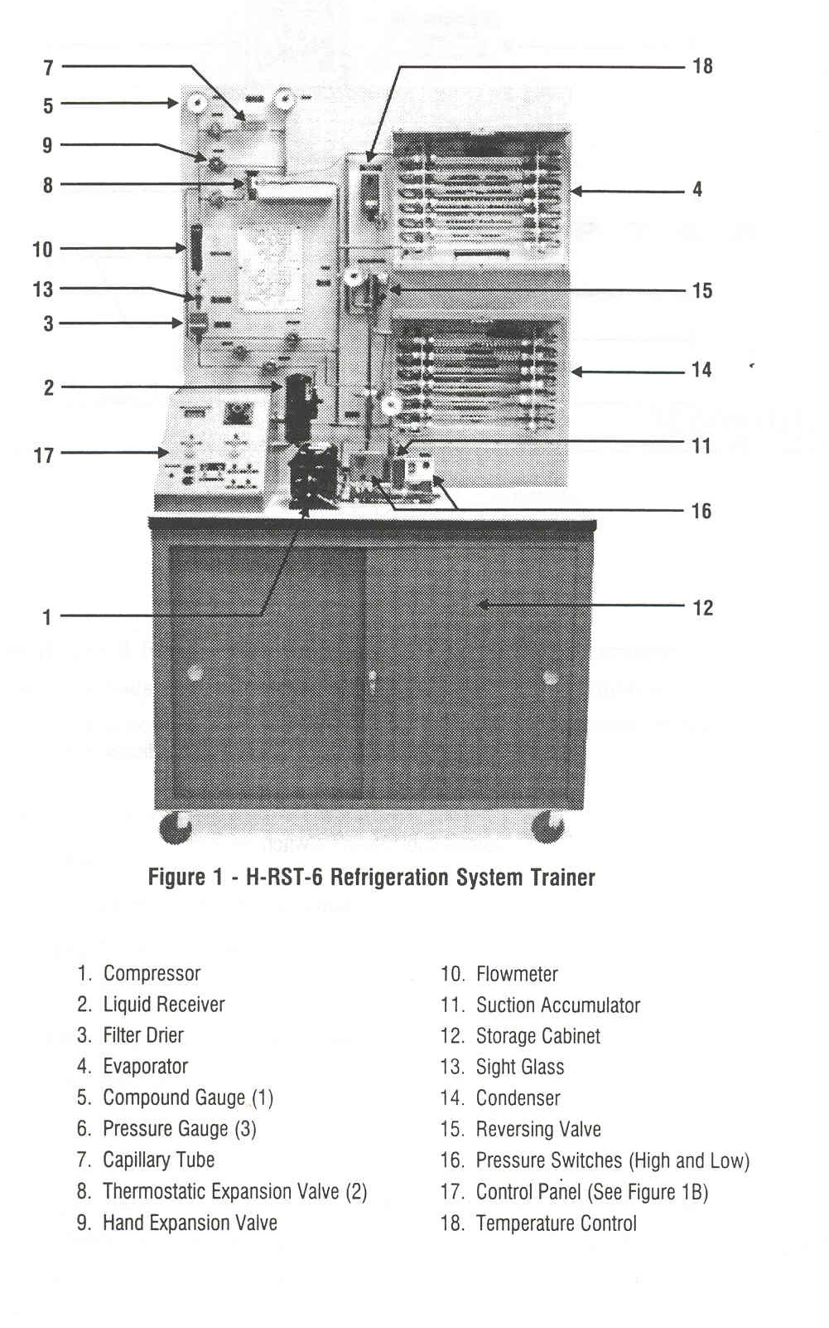
Figure 1: Air Conditioning Cycle Trainer.
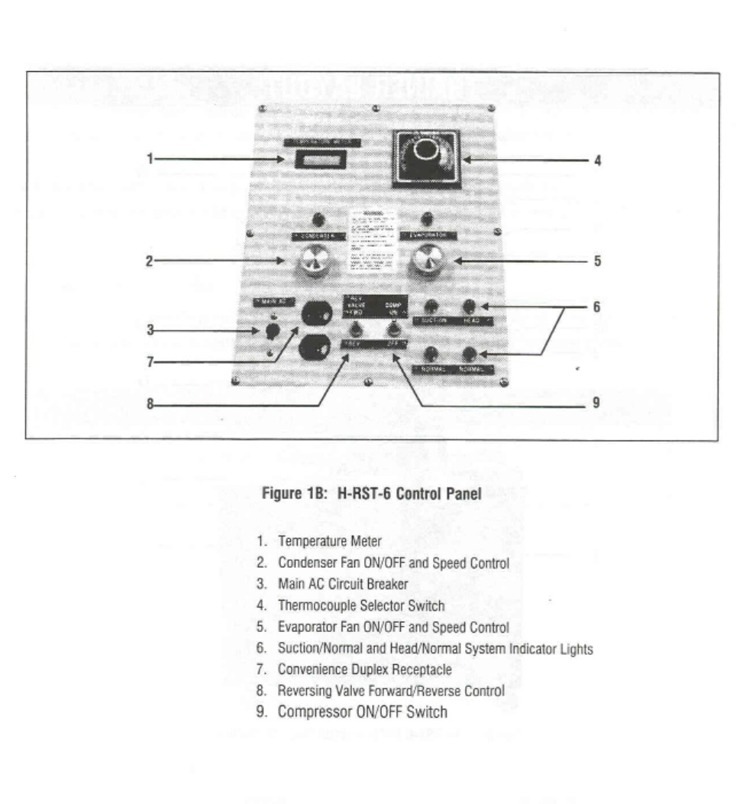
Figure 2: Air Conditioning Control Panel.

The Hampden H-RST-6 Refrigeration System trainer, Fig. 1, familiarizes students with the design concepts and the methods of operation of residential and light commercial refrigerating systems. The trainer is a completely functional mechanical refrigerating system. The trainer’s compact layout includes:
- 1450 BTU Hermetic Compressor,
- Liquid Receiver,
- Forced Air Evaporator (with load heater),
- High Pressure Control Switch,
- Low Pressure Control Switch,
- Filter/Drier and Sight Glass with moisture indicator,
- Temperature Control,
- Cycle Reversing Valve.

One of the three liquid control devices (Capillary Tube, Thermostatic Expansion Valve, or Hand Expansion Valve) may be used, illustrating different operating characteristics. Further, the system is capable of reverse cycle operation to demonstrate heat pump principles. The temperatures at six various location, see Fig. 2, may be monitored by using the thermocouple selector switch and panel temperature meter. Gauges indicate high-side (condensing) pressure and low-side (evaporating) pressure. Clear tubes help the students to understand the refrigerant change of state in the evaporator and condenser.

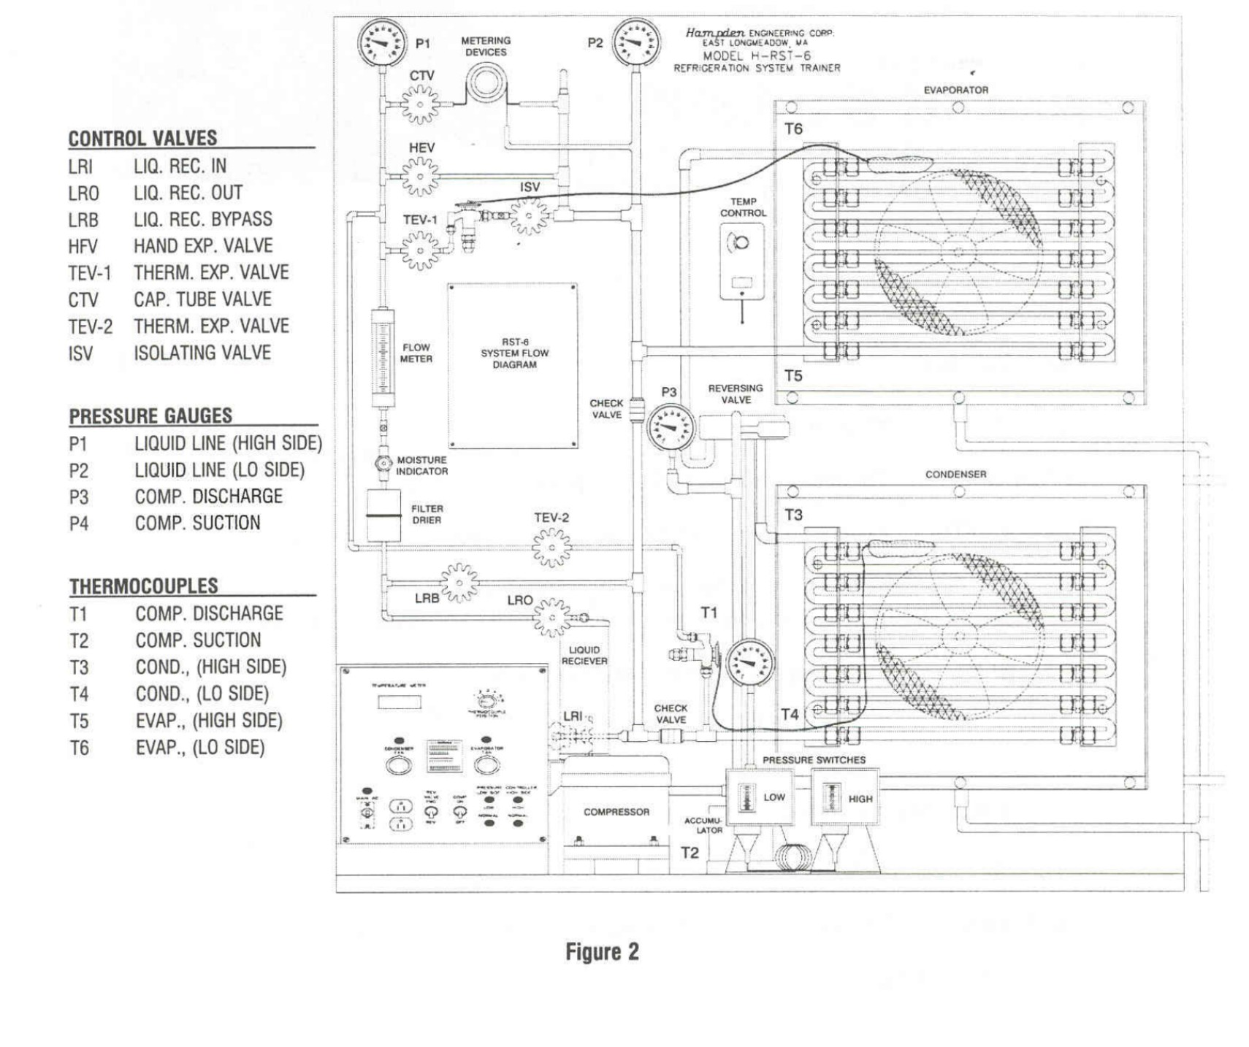
Figure 3: Air Conditioning Schematic.

Hand Valves:
- CTV: Opens and closes the liquid line to the Capillary Tube liquid control device.

- TEV-1: Cooling valve opens and closes the liquid line to the Thermostatic Expansion Valve liquid control device.

- HEV: Hand Expansion Valve liquid control device.

- LRI: Opens and closes the inlet to the Liquid Receiver.

- LRO: Opens and closes the outlet of the Liquid Receiver.

- LRB: Provides a fluid path to by-pass the liquid receiver. Open when LRI and LRO are closed.

- TEV-2: Heating

Control Switches:
- MAIN AC: Main AC circuit breaker
- CONDENSER: Condenser fan ON/OFF and speed control.
- EVAPORATOR: Evaporator fan ON/OFF and speed control.
Note: For maximum speed on the fan controls, just click the fan on. DO NOT turn the control anymore clockwise. Fully clockwise is the slowest fan speed.
- REV. VALVE: Reversing Valve, forward and reverse control.
- COMP: Compressor ON/OFF switch.

System Status Indicator Lights:
- NORMAL indicator lights should be on during normal operation.
- The LOW SIDE light will come on if the compressor shuts off due to low pressure.
- The HIGH SIDE light will come on if the compressor shuts off due to high pressure.

principles of Operation

Compression Cycle:
There are two pressures existing in a compression system, the evaporating or low pressure, and the condensing or high pressure. The refrigerant acts as a transportation medium to move heat from the evaporator to the condenser where heat is given to the ambient air, or in a water-cooled system, to the cooling water. A change of state from liquid to vapor and back to liquid allows the refrigerant to absorb and discharge large quantities of heat efficiently.

Compressor:
The compressor has two functions in the compression refrigeration cycle. First, it removes the refrigerant vapor from the evaporator and reduces the pressure in the evaporator to a point where the desired evaporating temperature can be maintained. Second, the compressor raises the pressure of the refrigerant vapor to a level high enough such the saturation temperature is higher than the temperature of the cooling medium for condensing the refrigerant.

Condenser:
The condenser is basically a heat exchanger where the heat absorbed by the refrigerant during the evaporating process is given to the condensing medium. The heat expelled by the condenser is always greater than heat absorbed during the evaporating process because of the heat compression. As heat is radiated by the high temperature, high pressure vapor; the temperature of the medium falls to the saturation point and the vapor condenses to a liquid.

Liquid Receiver:
The liquid receiver lies in the high pressure side, between the condenser and liquid control device. If the liquid refrigerant flowing from the condenser contains any vapor, the vapor is separated in the receiver. The outlet is near the bottom; thus, the only liquid flows out of the receiver. This feature allows the quantity of refrigerant to be less critical. The liquid receiver serves as a storage tank for liquid refrigerant.
Filter-Drier:
Moisture is one of the basic enemies of a refrigeration system, and the moisture level in an operating system must be held to an acceptable low level to avoid system malfunctions; such as, compressor damage. Even with the best precautions, moisture can enter a system during field service. If the system is thoroughly evacuated and recharged after exposure to moisture, the only effective means of removing small amounts of moisture is with a dehydrator.

Suction Accumulator:
The compressor can be damaged by liquid refrigerant. Therefore, a suction accumulator is placed just before the compressor to trap any liquid that my come from the evaporator. Since liquid is heavier than vapor, the liquid falls to the bottom. The outlet connection is in the lid, so only vapor leaves the accumulator.

Thermostat:
The purpose of the thermostat in a refrigerating system is to maintain the temperature of the cooled space at the set-point. The operator defines the desired temperature on the thermostat dial. The sensing bulb monitors the actual temperature. When set temperature is below actual temperature the thermostat switch closes, allowing the compressor to turn ON. The actual turn-on is delayed ten seconds to prevent damage to the compressor by rapid ON/OFF cycling.

Thermostatic Expansion Valve (TEV):
The most commonly used device for controlling the flow of liquid refrigerant into the evaporator is the thermostatic expansion valve. An orifice in the valve meters the flow into the evaporator, the rate of flow is modulated by a needle type plunger and seat, which varies the orifice opening.

Hand Expansion Valve (HEV):
The hand expansion valve is the least precise liquid control device equipped on the H-SRT-6. A needle valve controls the rate of refrigerant flow into the evaporator and is adjusted manually. The degree adjustment is dependent on system load, and capacity of the evaporator and the type of refrigerant.

Evaporator:
The evaporator is part of the low pressure side of the refrigeration system where liquid refrigerant boils or evaporates, absorbing heat as it changes into vapor. This accomplishes the purpose of the system-refrigeration.

Reversing Valve:
In recent years, usage of the “heat pump” principle to enable an air conditioning unit to supply both cooling and heating has become increasingly popular. Basically this involves switching the functions of the evaporator and condenser by a change in refrigerant flow as desired, so that the indoor coil becomes the evaporator for cooling purpose, and the condenser for heating usage. The outdoor coil in turn is a condenser during the cooling cycle, and an evaporator during the heating cycle.

High-Low Pressure Controls:
One of the most harmful things that can happen to a hermetic system is to have high condensing pressures. These high pressures raise the temperature of the vapor and oil moving past the compressor exhaust valve to a point which may cause oil and refrigerant breakdown. Additionally harmful, if a little moisture and dirt are present; carbon, acids, and sludge may form.

Laboratory Procedure:
- Locate all components as listed on Fig. 1 and 2.

- Locate all valves as listed in Fig. 3.

  - WARNING! - Do not touch any pipes or non-essential components. They can become hot and there is a risk of burns.

Part 1: (REQUIRED)

This section is the starting condition for all other cases. This condition should be running
before proceeding to any other case. This condition is cooling using a Thermal Expansion
Valve (TEV).

- Open valves LRI, LRO, TEV-1, and ISV.

- Check that valves LRB, CTV, HEV, and TEV-2 are closed. Close these valves if required.

- Check that the reversing valve switch is in the FWD position.

- Switch ON the Main AC.

- Turn on the compressor switch, condenser fan, and evaporator fan. (The highest fan speed is achieved when the control is first activated. The fan speed will decrease as the control is turned clockwise.)

- Allow system to stabilize (observe the temperatures and flow rates throughout the system, when these items no longer fluctuate the system has stabilized).

- Observe the flow of the refrigerant and make note of the refrigerant condition, (record in Table 1).

- Record the temperature, flow, and pressure readings as noted in Table 1, Part 1.

Part 2: (OPTIONAL)

This condition is cooling using a Hand Expansion Valve (HEV).

- Check that the system is running and stabilized under Part 1 conditions.

- Open the HEV slightly and close the TEV-1 valve.

- Adjust the HEV to maintain P3 at approximately 150 psig.

- Allow system to stabilize (observe the temperatures and flow rates throughout the system, when these items no longer fluctuate the system has stabilized).

- Observe the flow of the refrigerant and make note of the refrigerant condition, (record in Table 2).

- Record the temperature, flow, and pressure readings as noted in Table 2, Part 2.

- Open TEV-1 and close the HEV to return the system to the condition of Part 1.

Part 3: (OPTIONAL)

This condition is cooling using a Capillary Tube Control

- Verify the system is running and stabilized under Part 1 conditions.

- Close the LRI and LRO.

- Open the LRB and CTV

- Close the TEV-1.

- Allow system to stabilize (observe the temperatures and flow rates throughout the system, when these items no longer fluctuate the system has stabilized).

- Observe the flow of the refrigerant and make note of the refrigerant condition, (record in Table 3).

- Record the temperature, flow, and pressure readings as noted in Table 3, Part 3.

- Open the TEV-1.

- Close the LRB and CTV.

- Open the LRI and LRO.

Shutdown Procedure:

- Verify the unit is running and stabilized under Part 1 conditions.

- Close the LRO first, then CTV, HEV, TEV-1, LRB, and ISV valves.

- The evaporator pressure will decrease until it reaches the compressor cut-out setting.

- Turn OFF the compressor, evaporator fan, condenser fan, and main AC switches.

- Unplug the system AC cord.

Data Reduction and Questions:

- Considering the table 4, determine the enthalpy at each thermocouple location for Part (1-3).

- Draw the cycle on a P-h diagram for Part (1-3) from the collected data.

- Calculate the heat transfer rate through the condenser.

- Calculate the heat transfer rate through the evaporator.

- Calculate the isentropic efficiency of the compressor.

- Calculate the ideal cycle C.O.P. and the actual C.O.P.

- Comment on your findings and any observations that were made during the experiment.
Air Conditioning Data Sheets:

Table 1: Air Conditioning Data

Air Conditioning Data Entry 1
Ambient Temp. |  |  | Ambient Pres.
Observations
Air Conditioning Part 1
Temperature (°F) |  |  |  | Enthalpy (BTU/lb)
T1 Comp. Out |  |  |  | h1
T2 Comp. In |  |  |  | h2
T3 Cond. In |  |  |  | h3
T4 Cond. Out |  |  |  | h4
T5 Evap. In |  |  |  | h5
T6 Evap. Out |  |  |  | h6
High Pressure,P4 (PSI) |  | Low Pressure,P2 (PSI) |  | Flowmeter reading |  | Flowrate (lb/min)

Table 2: Air Conditioning Data

Air Conditioning Data Entry 2
Air Conditioning Part 2
Temperature (°F) |  | Enthalpy (BTU/lb)
T1 Comp. Out |  | h1
T2 Comp. In |  | h2
T3 Cond. In |  | h3
T4 Cond. Out |  | h4
T5 Evap. In |  | h5
T6 Evap. Out |  | h6
High Pressure,P4 (PSI) | Low Pressure,P2 (PSI) | Flowmeter reading | Flowrate (lb/min)

Table 3: Air Conditioning Data
Air Conditioning Part 3
Temperature (°F) |  | Enthalpy (BTU/lb)
T1 Comp. Out |  | h1
T2 Comp. In |  | h2
T3 Cond. In |  | h3
T4 Cond. Out |  | h4
T5 Evap. In |  | h5
T6 Evap. Out |  | h6
High Pressure,P4 (PSI) | Low Pressure,P2 (PSI) | Flowmeter reading | Flowrate (lb/min)

Table 4: Flow Meter Data
Flow Meter Data
Meter Reading | Flowrate (lb/min) | Meter Reading | Flowrate (lb/min) | Meter Reading | Flowrate (lb/min)
100 | 1.91 | 68 | 1.26 | 36 | 0.59
98 | 1.87 | 66 | 1.22 | 34 | 0.56
96 | 1.84 | 64 | 1.18 | 32 | 0.52
94 | 1.80 | 62 | 1.14 | 30 | 0.48
92 | 1.76 | 60 | 1.09 | 28 | 0.44
90 | 1.72 | 58 | 1.05 | 26 | 0.40
88 | 1.68 | 56 | 1.01 | 24 | 0.36
86 | 1.64 | 54 | 0.97 | 22 | 0.33
84 | 1.60 | 52 | 0.92 | 20 | 0.29
82 | 1.55 | 50 | 0.88 | 18 | 0.25
80 | 1.51 | 48 | 0.84 | 16 | 0.22
78 | 1.47 | 46 | 0.80 | 14 | 0.18
76 | 1.43 | 44 | 0.76 | 12 | 0.14
74 | 1.39 | 42 | 0.72 | 10 | 0.11
72 | 1.35 | 40 | 0.68 | 8 | 0.07
70 | 1.31 | 38 | 0.63 | 6 | 0.03

